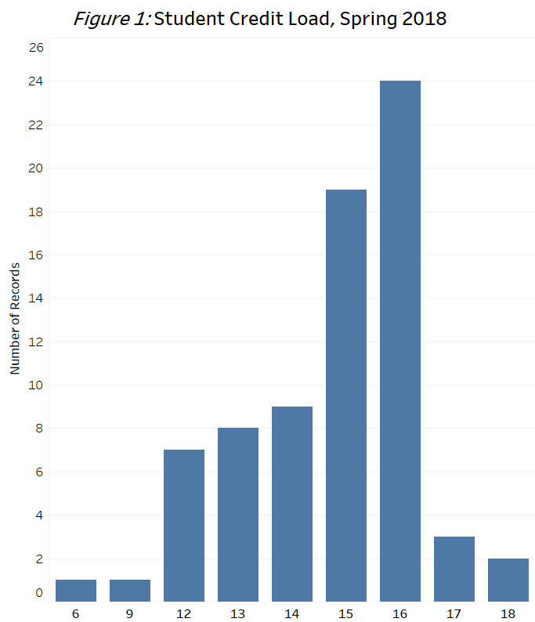
The Situation
Very Interesting Study
With an Intriguing Subtitle
October 5, 2018
Intriguing opening sentence but getting quickly to the point. This introductory paragraph will convince the reader that this short report is important and interesting. It will also set up what type of analysis is in the report and share the conclusions. This is not a novel, after all, you should spoil the ending with a one sentence conclusion.
Findings

KEY FINDINGS
x% of branches are in the lowest category of stability
5 OUT OF 4 PEOPLE HAVE TROUBLE WITH FRACTIONS
70% OF THE TIME, IT WORKS EVERY TIME.

Describe the data, including the source, the variables you analyze and how they are measured. Cite Figure 1 and give a sentence to what it illustrates.
A picture says a thousand words. Here is where you tell

the story and fill in those words. Blah blah blah blah blah blah. Blah blah blah blah blah blah blah. Blah blah blah blah blah blah. Blah blah blah blah blah blah blah. Blah blah blah blah blah blah. Blah blah blah blah blah blah blah. Blah blah blah blah blah blah. Blah blah blah blah blah blah blah. Blah blah blah blah blah blah. Blah blah blah blah blah blah blah. Blah blah blah blah blah blah. Blah blah blah blah blah blah blah. Blah blah blah blah blah blah. Blah blah blah blah blah blah blah. Blah blah blah blah blah blah. Blah blah blah blah blah blah blah.
Hdfjashfdjksahdfjkhsakjdfkjsahfdjklsajdhfjklkjhjklhdsakjdhfkjhkjsdahdkjfhkjlsakjdhfkjshdafkjhskdjfhskjdhfkjsdhfkjshdfkjshdkjfhskjdhfkjsadhfkjshdfwuiehtroiuyweiouthuioerhtogieh;

[Grab your reader’s attention with a great quote from the document or use this space to emphasize a key point. To place this text box anywhere on the page, just drag it.]
More Depth
Go into more depth on your analysis. Introduce another figure and tell your audience what it means.
Blah blah blah blah blah blah blah blah. Blah blah blah blah blah blah blah blah. Blah blah blah blah blah blah blah blah. Blah blah blah blah blah blah blah blah. Blah blah blah blah blah blah blah blah. Blah blah blah blah blah blah blah blah. Blah blah blah blah blah blah blah blah. Blah blah blah blah blah blah blah blah. Blah blah blah blah blah blah blah blah. Blah blah blah blah blah blah blah blah. Blah blah blah blah blah blah blah blah. Blah blah blah blah blah blah blah blah. Blah blah blah blah blah blah blah blah. Blah blah blah blah blah blah blah blah. Blah blah blah blah blah blah blah blah. Blah blah blah blah blah blah blah blah. Blah blah blah blah blah blah blah blah. Blah blah blah blah blah blah blah blah.
Use all of your space! Don’t leave whitespace here!
Recommendations
Or maybe call this section, “Conclusions.” Repeat your conclusion from the first section and expand upon it. Can you go into more details on the conclusion? Is there some more nuance worth repeating? What recommendations can you make from the analysis?

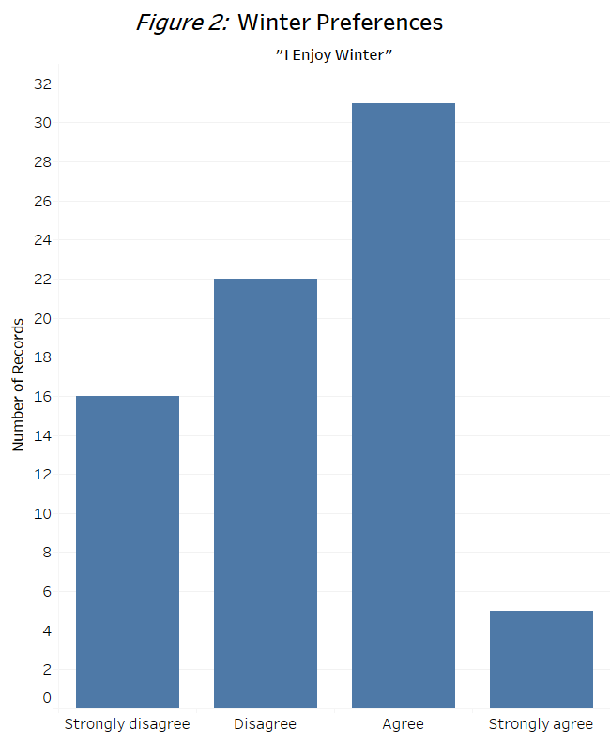

Prepared by: Joseph schmoseph, Marketing major University of Wisconsin – La Crosse

